**Lab 4**

**To Simplify Boolean Expressions and Implement Respective Digital Circuits Using Karnaugh Map**

**Note:** For examples, refer to the following link: <https://www.geeksforgeeks.org/introduction-of-k-map-karnaugh-map>

**Tasks**

1. **Construct K-Map for the function given below. Show the simplified output expression and verify the output with the help of software simulation.**

Z = f(A,B) = http://www.ee.surrey.ac.uk/Projects/Labview/minimisation/graphics/a.gifhttp://www.ee.surrey.ac.uk/Projects/Labview/minimisation/graphics/b.gif + A http://www.ee.surrey.ac.uk/Projects/Labview/minimisation/graphics/b.gif + http://www.ee.surrey.ac.uk/Projects/Labview/minimisation/graphics/a.gifB

K-Map

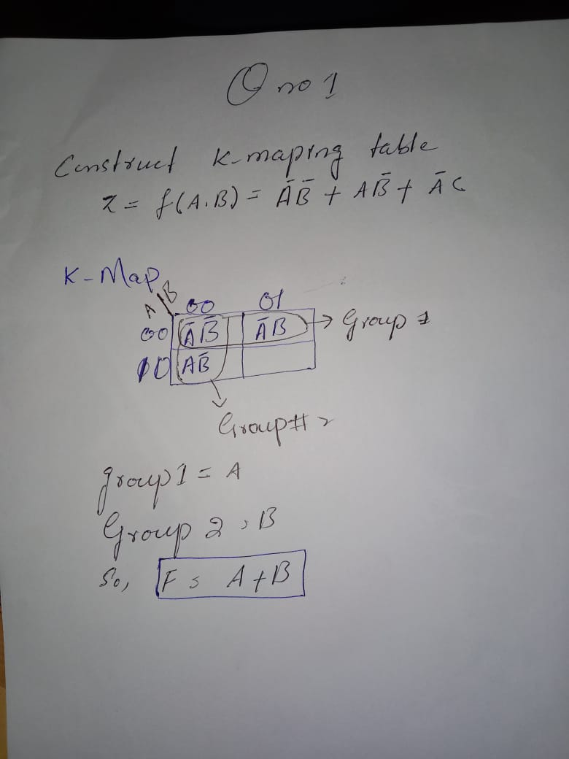

Simplified Output Function

F=A+B

Software Simulation of Logic Circuit From Simplified Function

(Show here your results for each combination)

inPUts are 111111 and output is 0

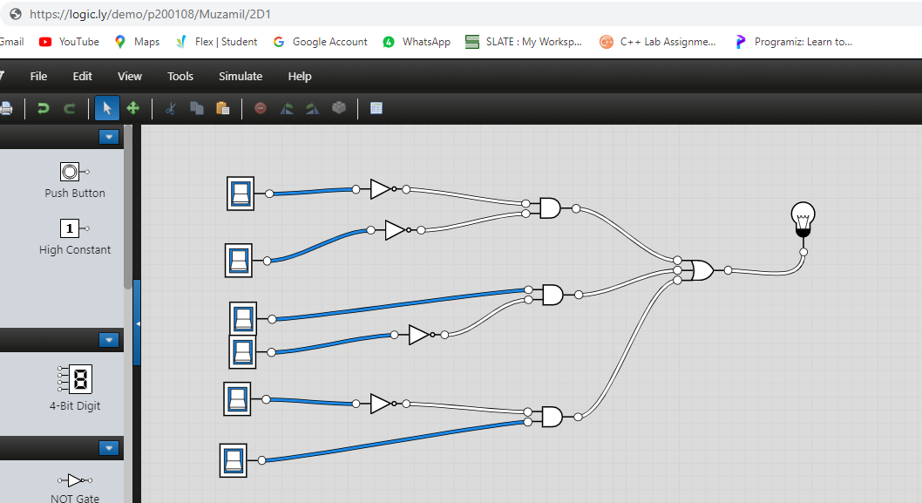

Inputs are 011111 and output is 0

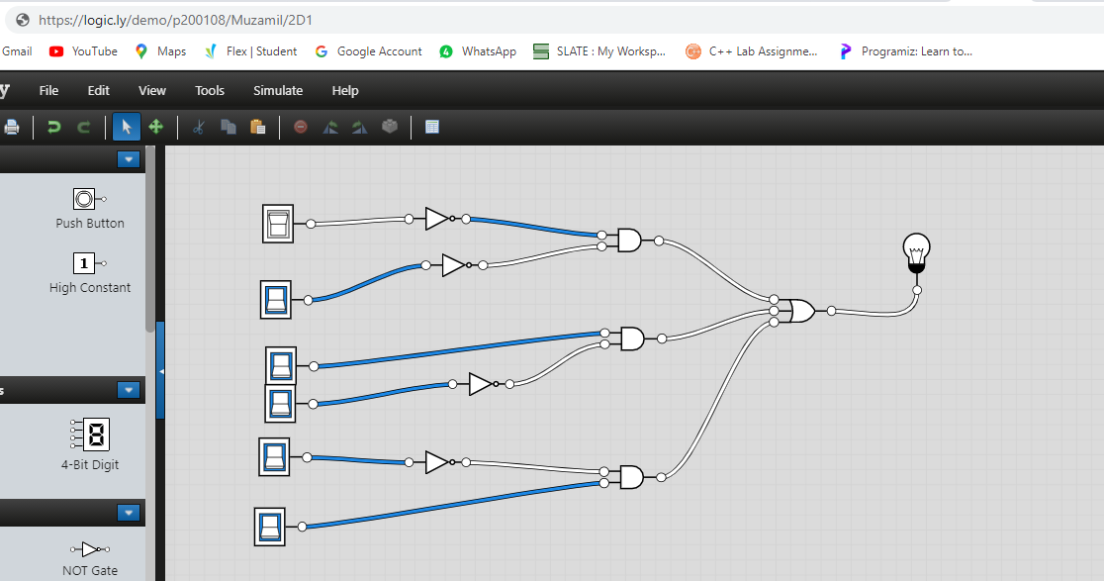

Inputs are 001111 and output is 1

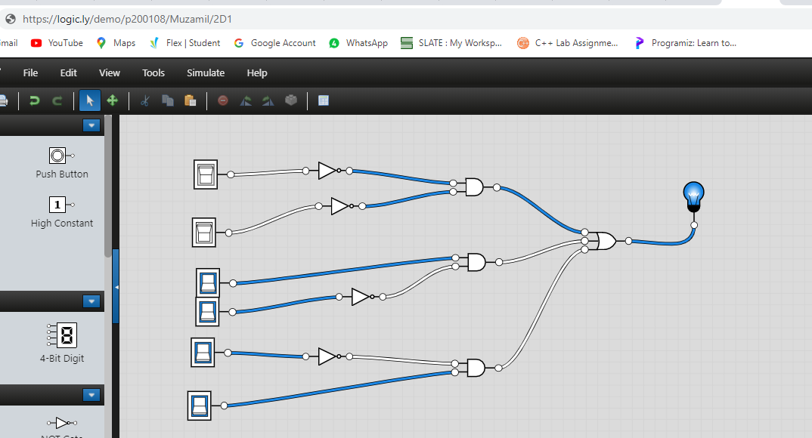

Inputs are 000111 and output is 1

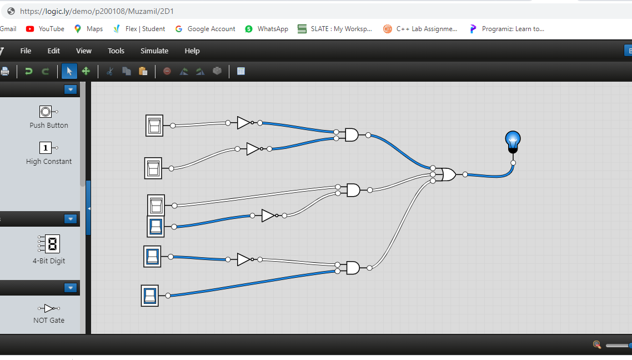

Inputs are 000000 and output is 1

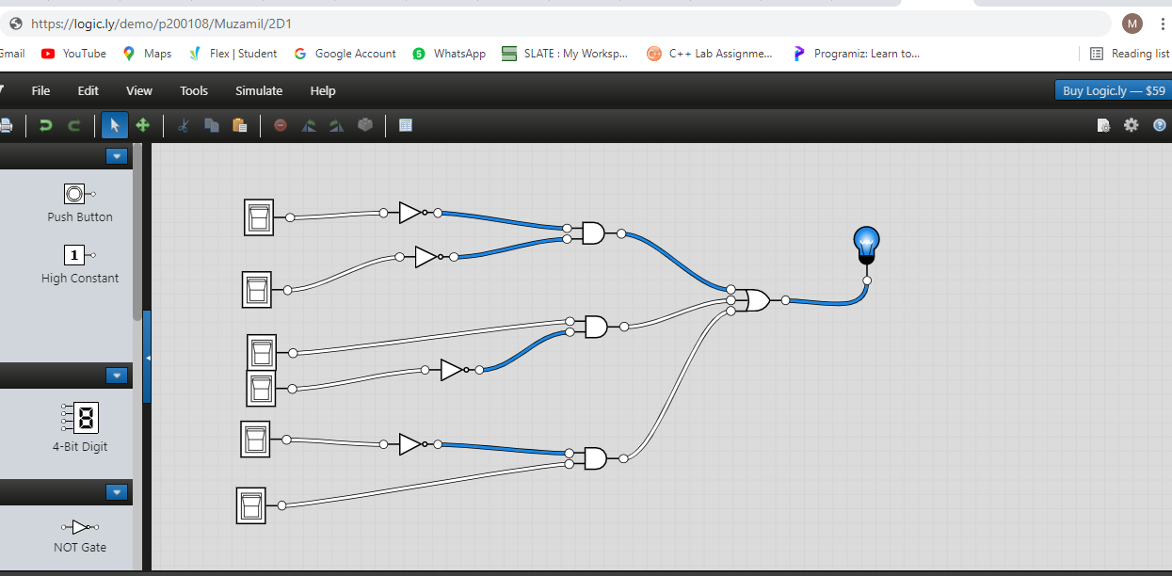

1. **Minimize the following function using K-Map. Verify the output expression with the help of simulation.**

f(a,b,c,d) = ∑m(3,7,11,12,13,14,15)

K-Map

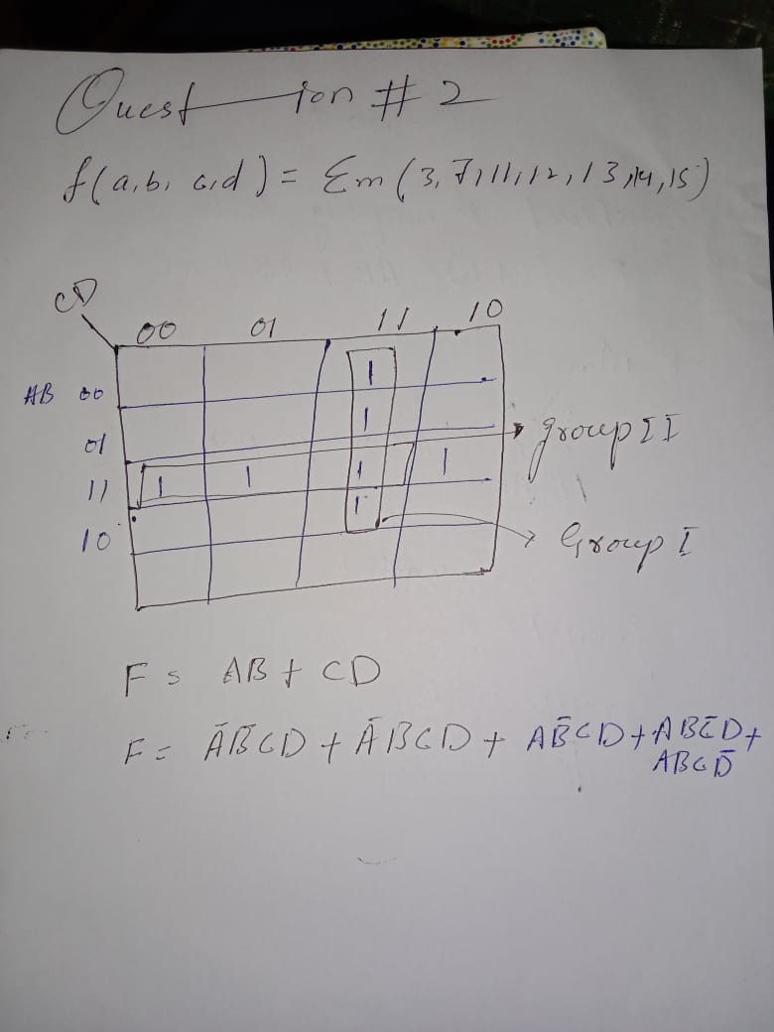

Simplified Output Function

F=AB+CD

Software Simulation of Logic Circuit From Simplified Function

Inputs are 0000 and output is 0

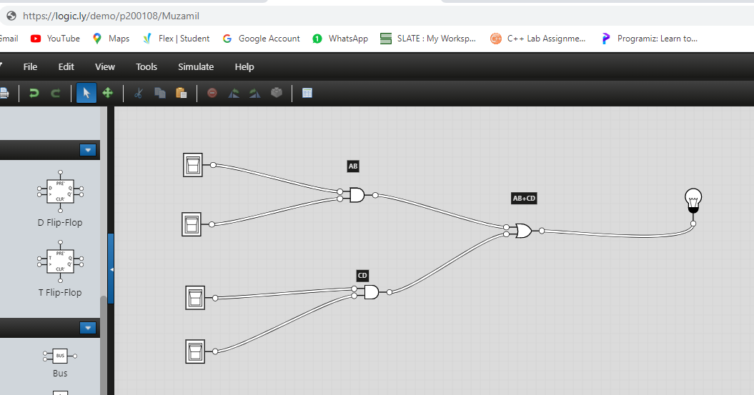

Inputs are 1000 and output is 0

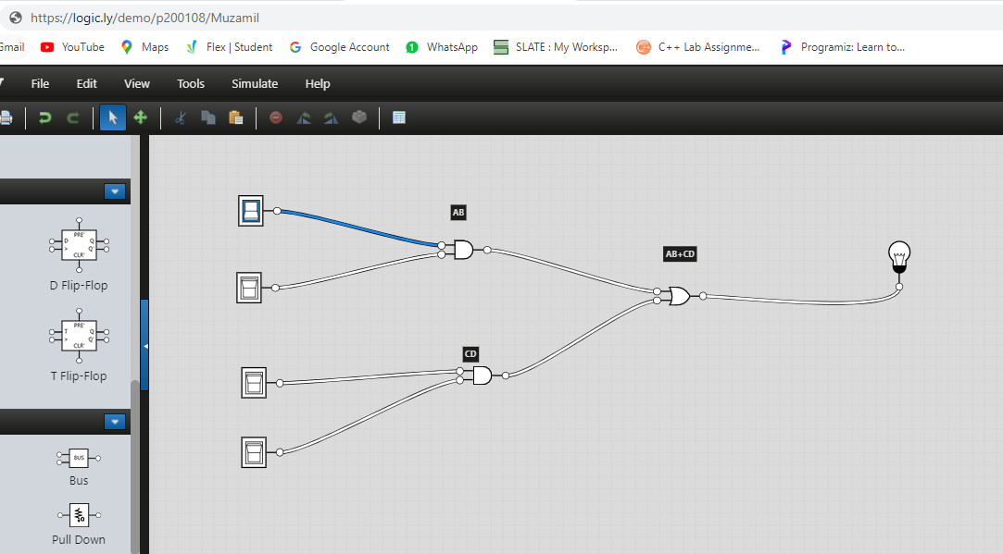

Inputs are 1100 and output is 1

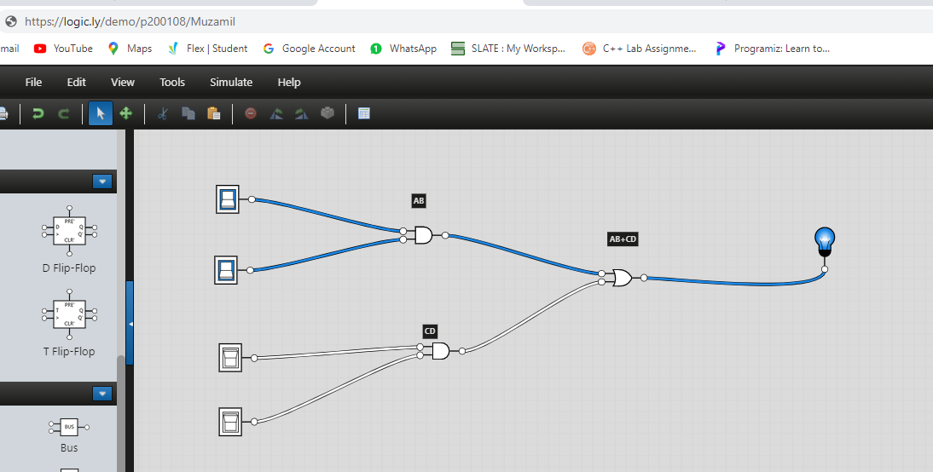

Inputs are 1110 and output is 1

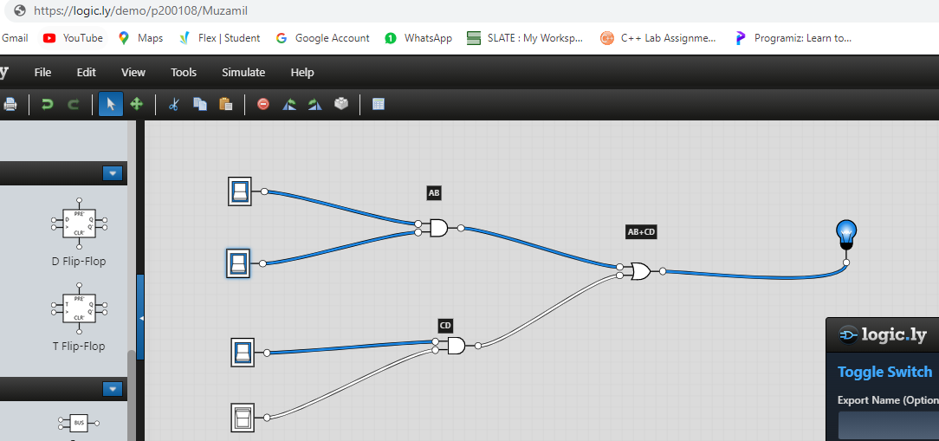

Inputs are 1111 and output is 1

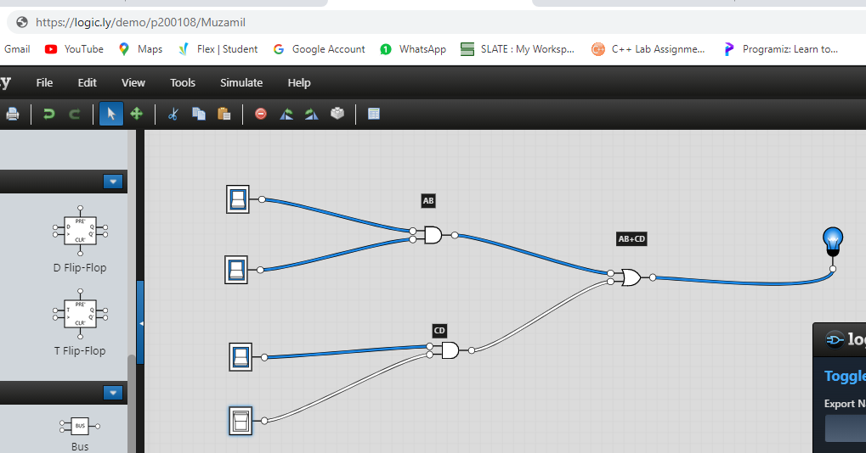

Inputs are 0001 and output is 0

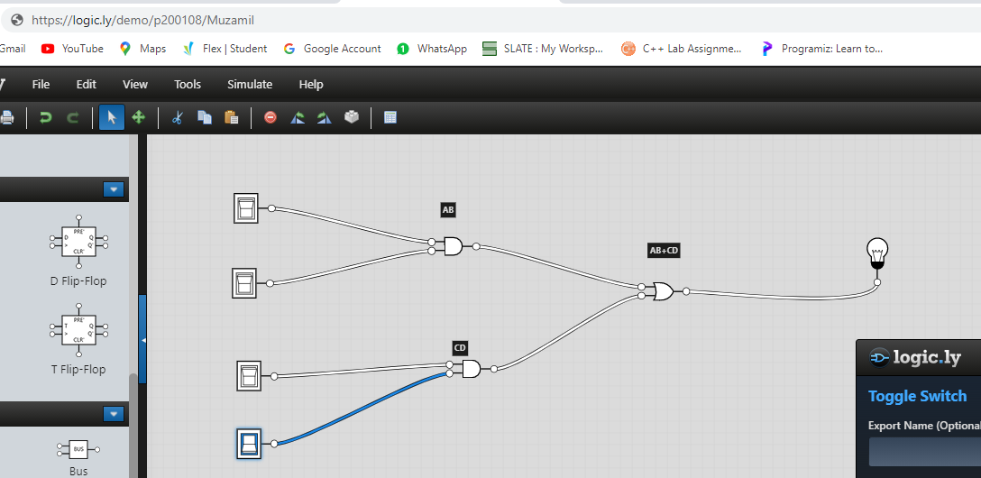

Inputs are 0011 and output is 1

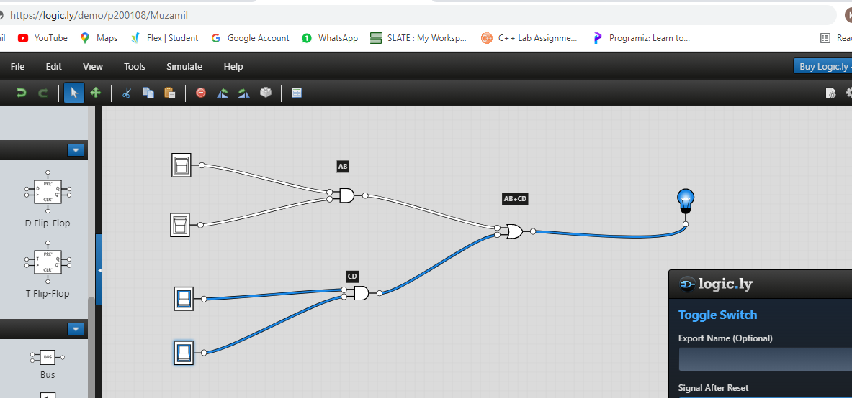

Inputs are 0111 and ouput is 1

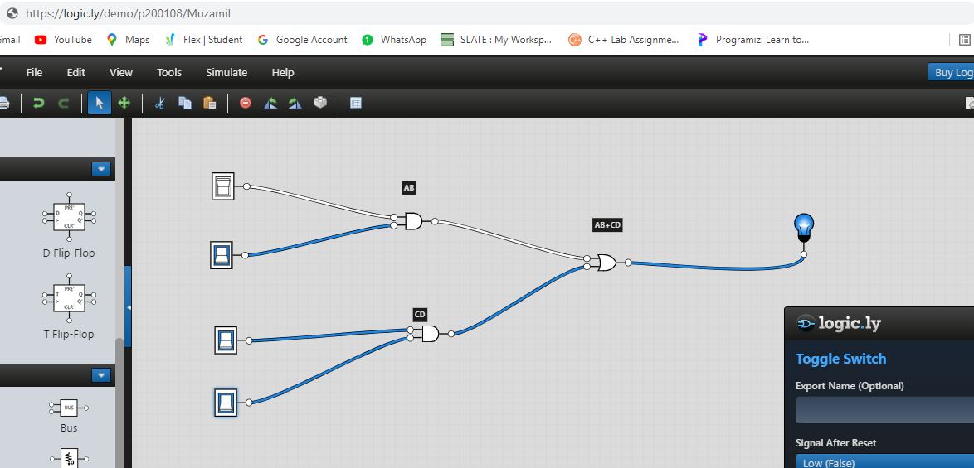

Inputs are 1011 and output is 1

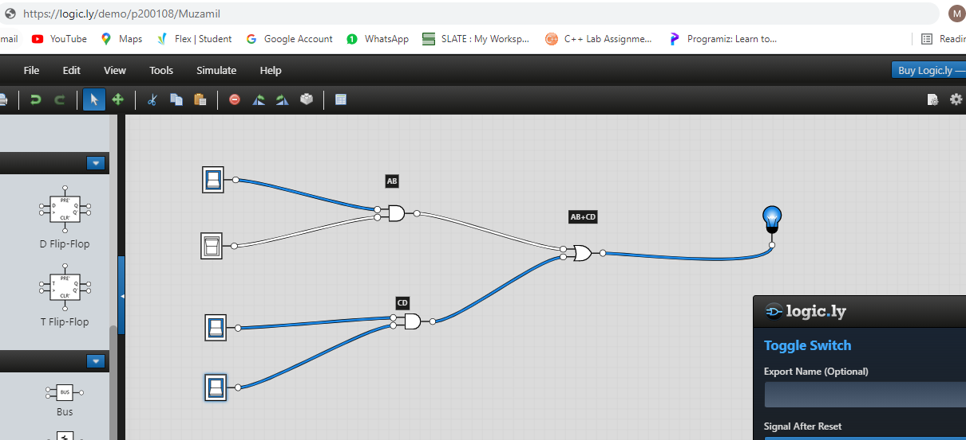

Inputs are 1001 and output is 0

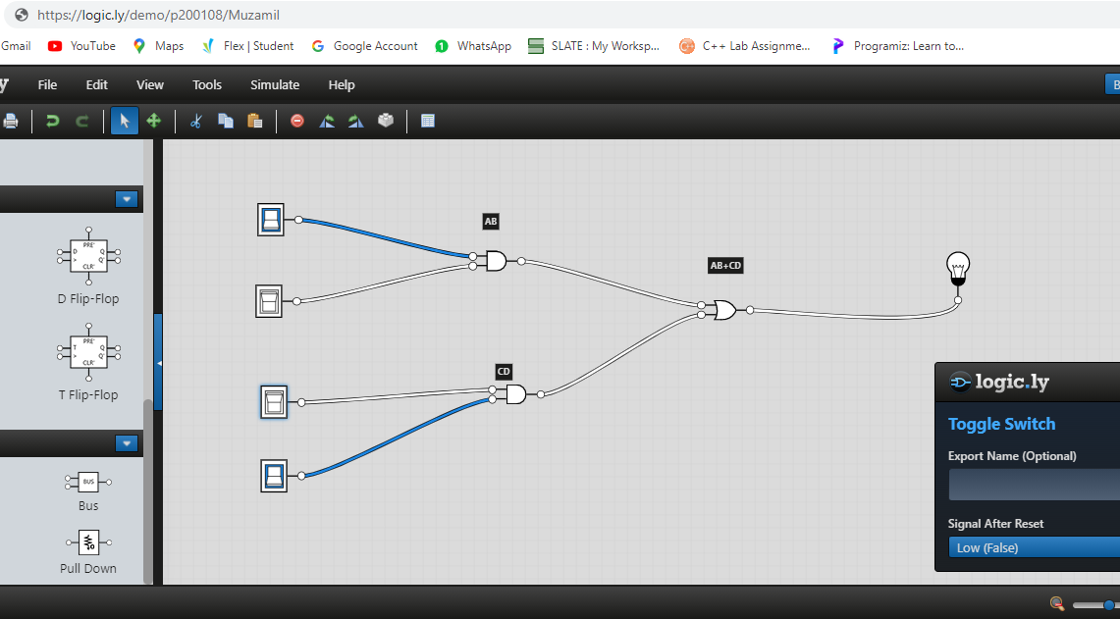

Inputs are 1101 and output is 1

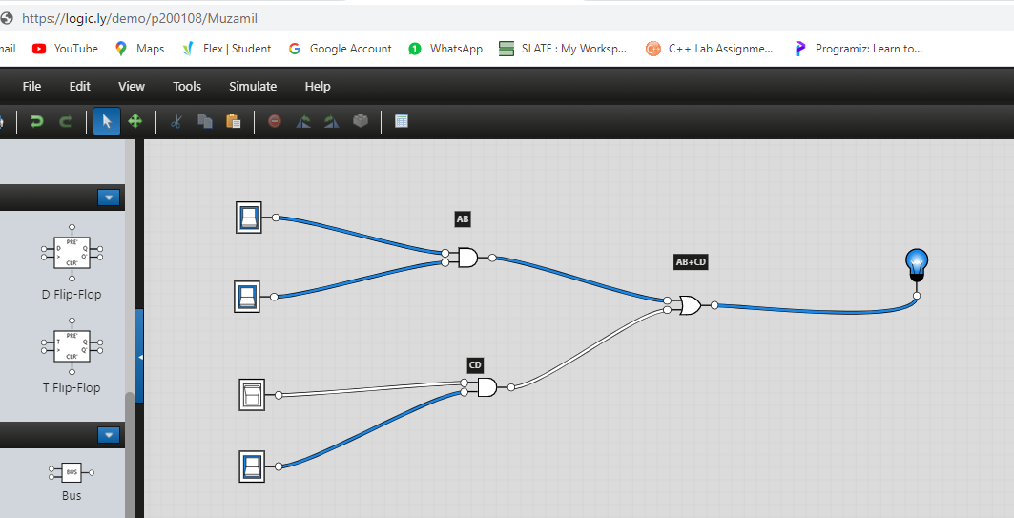

Etc…

1. **Construct K-Map for the given POS form given below. Simulate your final expression (reduced) and show the results.**

F(A,B,C,D)=**π**(3,5,7,8,10,11,12,13)

K-Map

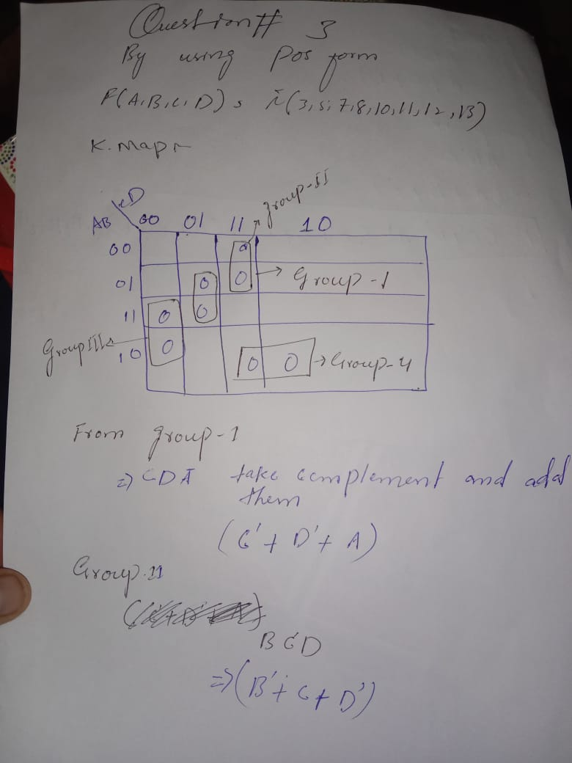

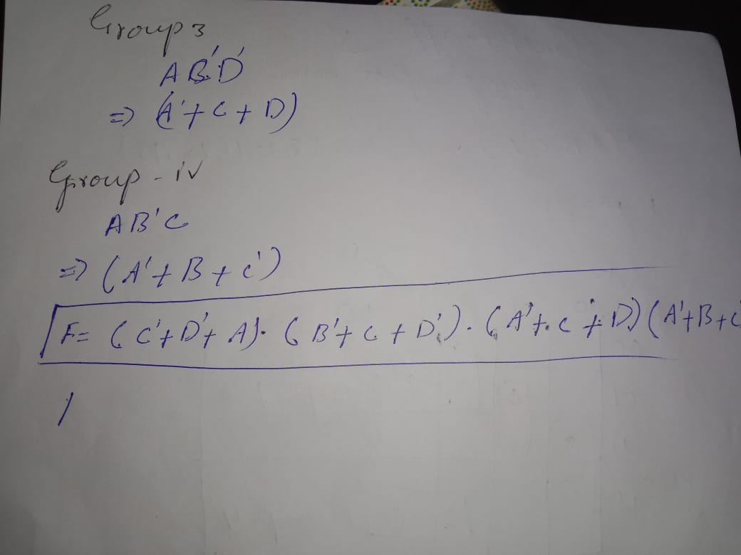

Simplified Output Function

F=(C’+D’+A).(B’+C+D’).(A’+C+D).(A’+B+C’)

Software Simulation of Logic Circuit From Simplified Function

INPUTS Are 100000000000 and Output is 1

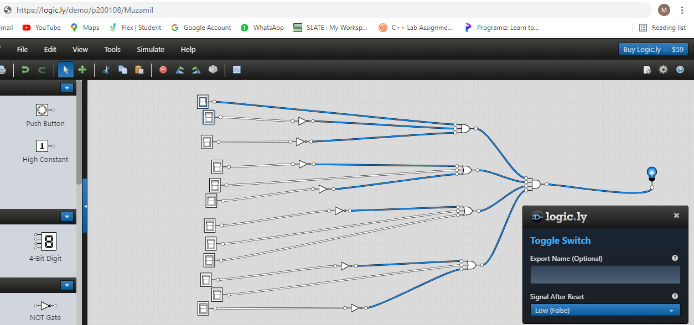

INPUTS Are 000000000000 and Output is 1

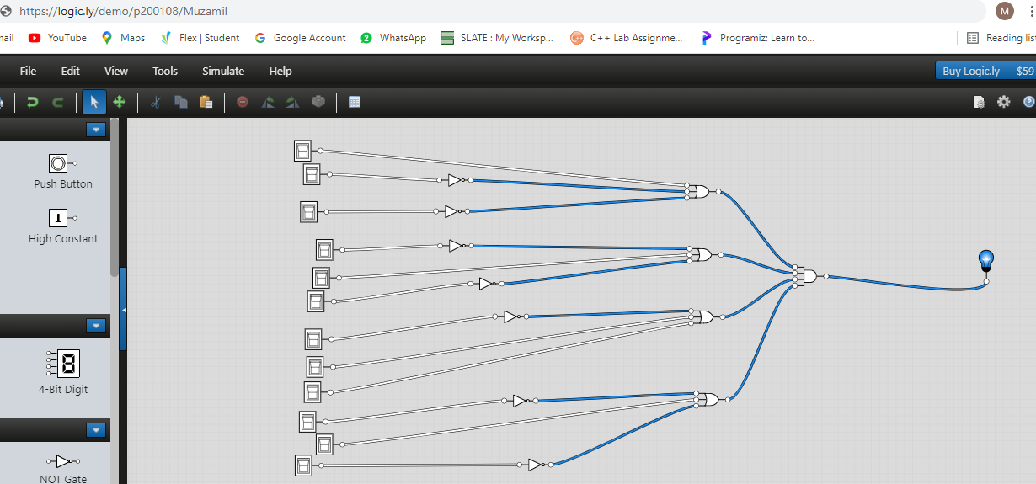

INPUTS Are 100000000000 and Output is 1

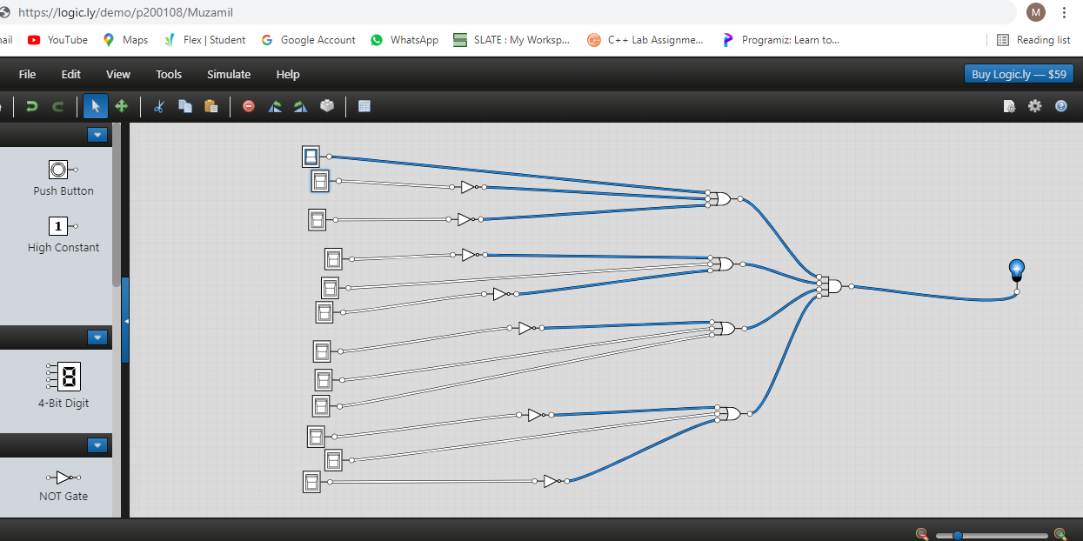

INPUTS Are 111000000000 and Output is 1

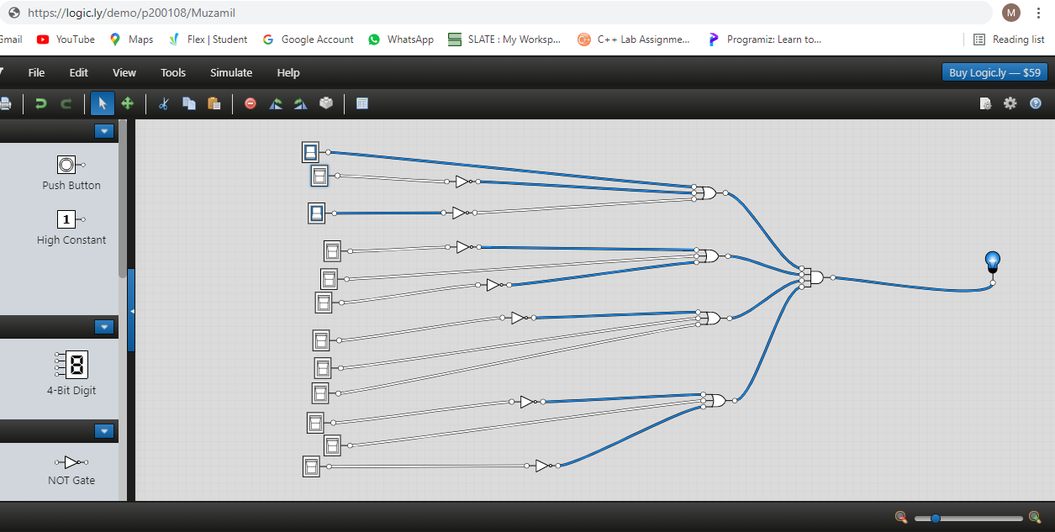

INPUTS Are 111100000000 and Output is 1

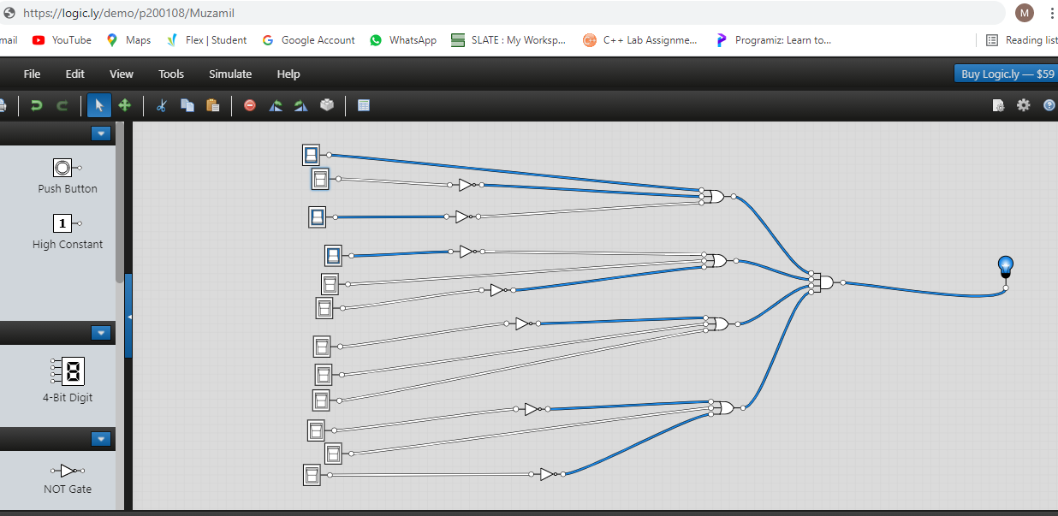

INPUTS Are 1111110000000 and Output is 1

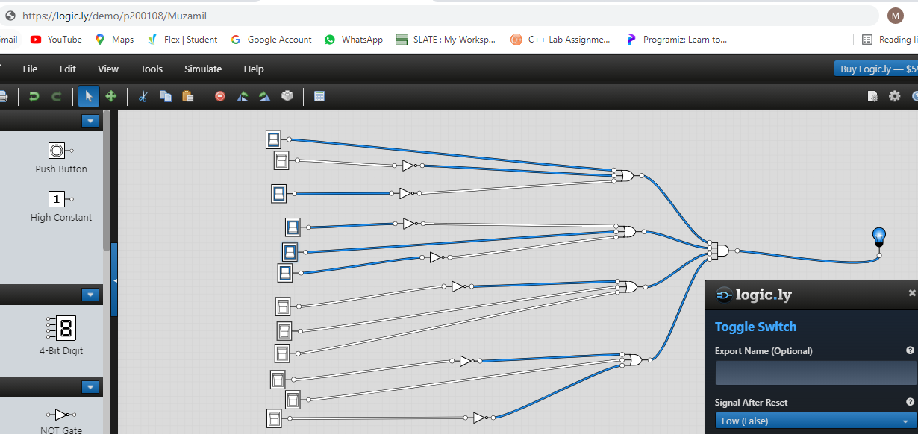

INPUTS Are 1111111000000 and Output is 0

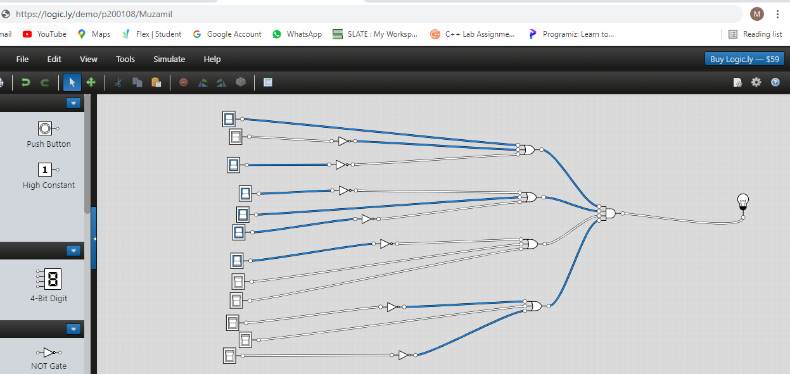

1. **Devise a minimized expression for the given truth table using K-Map (SOP form).**

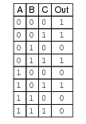

K-Map

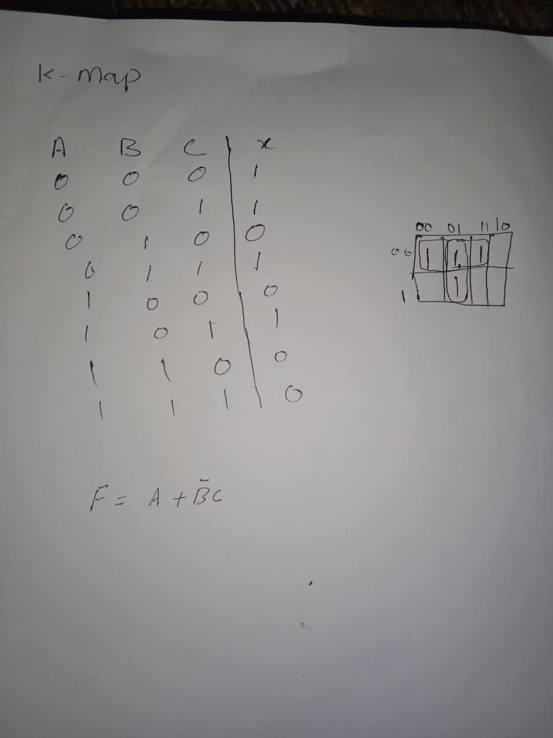

Expression

Output =F=A+B’C

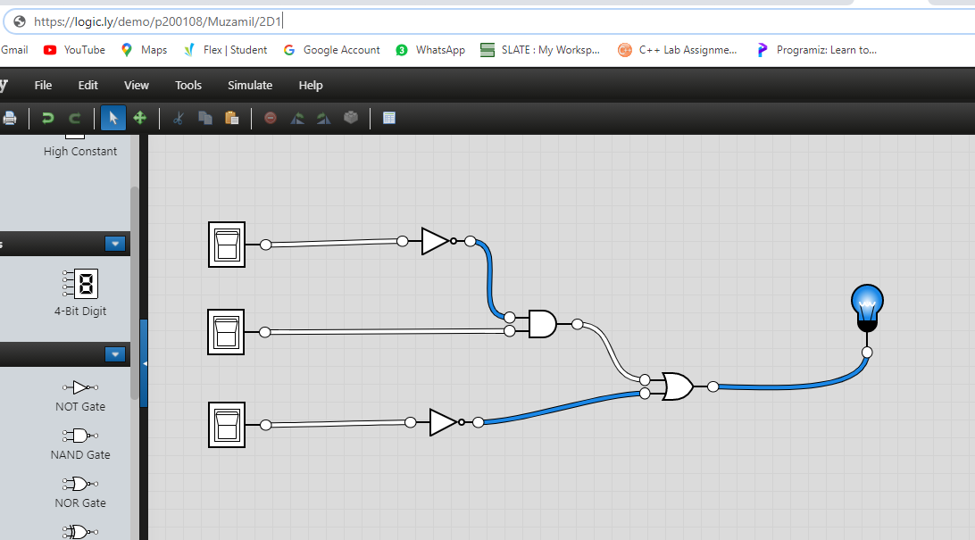

1. **For the above truth table, devise an expression in POS form using KMap.**

K-Map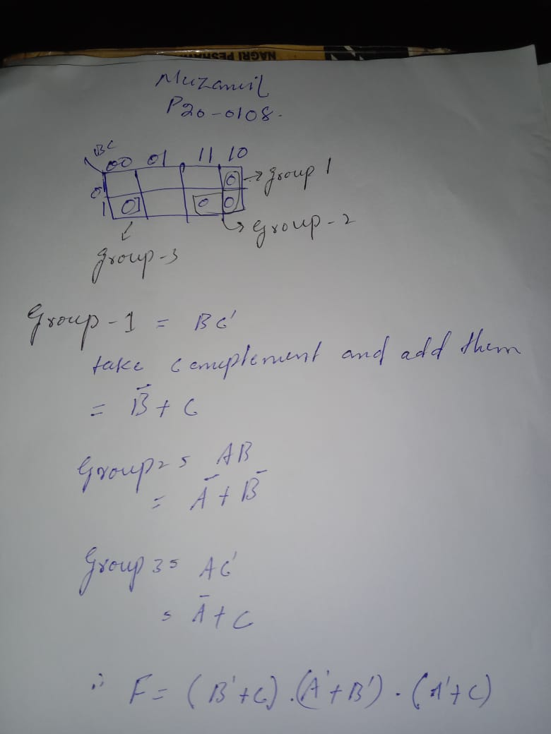

Expression

Expression

F=(B’+C)(A’+B’)(A’+C)

1. **Devise a truth table and Boolean expression for the given K-Map.**

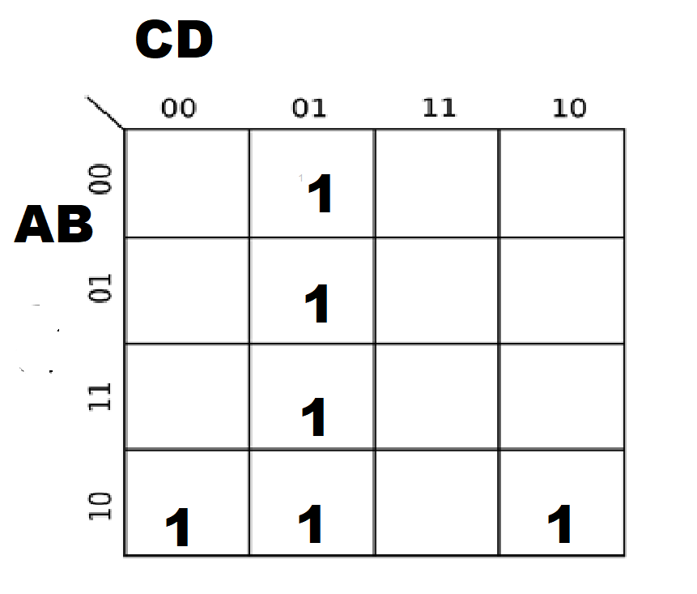

Truth Table

Truth Table

A B C D OUTPUT

|  |  |  |  |  |
| --- | --- | --- | --- | --- |
| 0 | 0 | 0 | 0 | 0 |
| 0 | 0 | 0 | 1 | 1 |
| 0 | 0 | 1 | 0 | 0 |
| 0 | 0 | 1 | 1 | 0 |
| 0 | 1 | 0 | 0 | 0 |
| 0 | 1 | 0 | 1 | 1 |
| 0 | 1 | 1 | 0 | 0 |
| 0 | 1 | 1 | 1 | 0 |
| 1 | 0 | 0 | 0 | 1 |
| 1 | 0 | 0 | 1 | 1 |
| 1 | 0 | 1 | 0 | 1 |
| 1 | 0 | 1 | 1 | 0 |
| 1 | 1 | 0 | 0 | 0 |
| 1 | 1 | 0 | 1 | 1 |
| 1 | 1 | 1 | 0 | 0 |
| 1 | 1 | 1 | 1 | 0 |

Expression

F= AB’C+C’D+AB’D

Muzamil

P20-0108